Test Case: tc004_SPX_Dev5_Validacion_Filtro_Campo_MenuName_Administrador_Menu
Step 1 - Enter username and password and click to button Enter : Credentials Entered
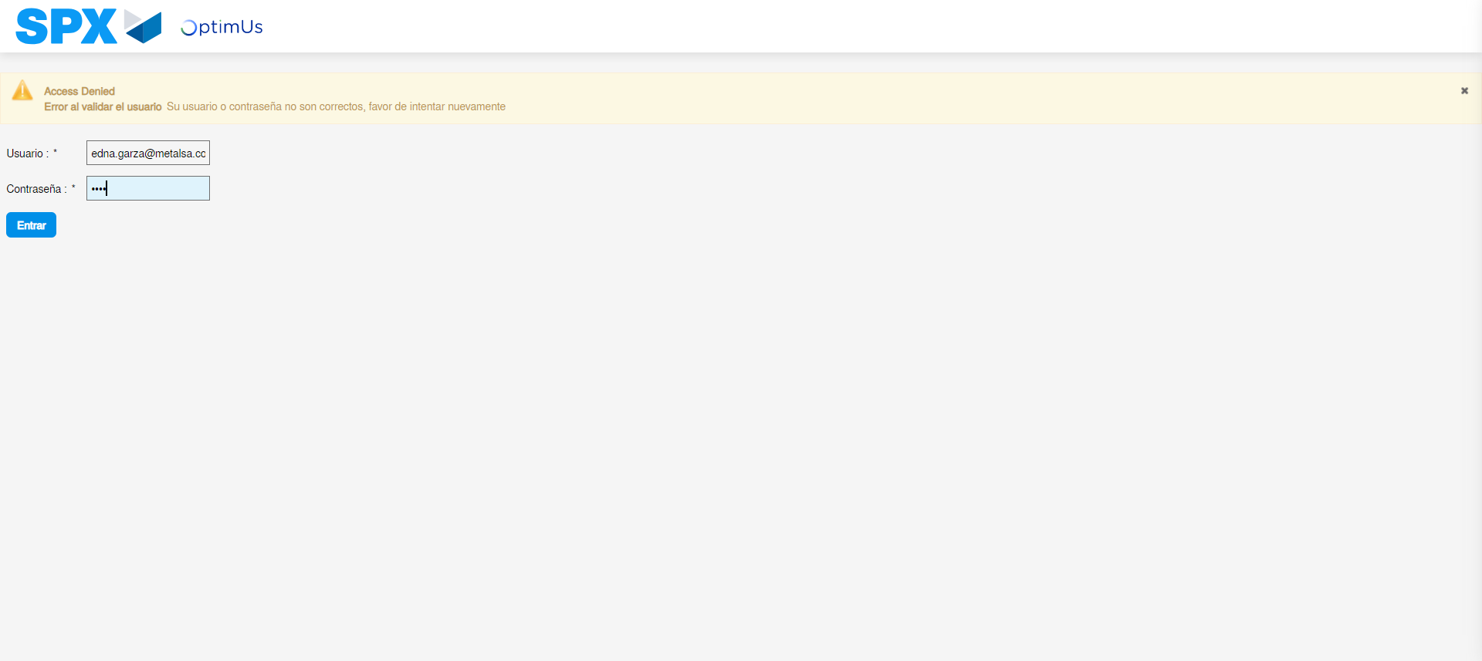Image file-name: QC_Testing-tc004_SPX_Dev5_Validacion_Filtro_Campo_MenuName_Administrador_Menu-may. 15 2024, 01 00 44 p. m.

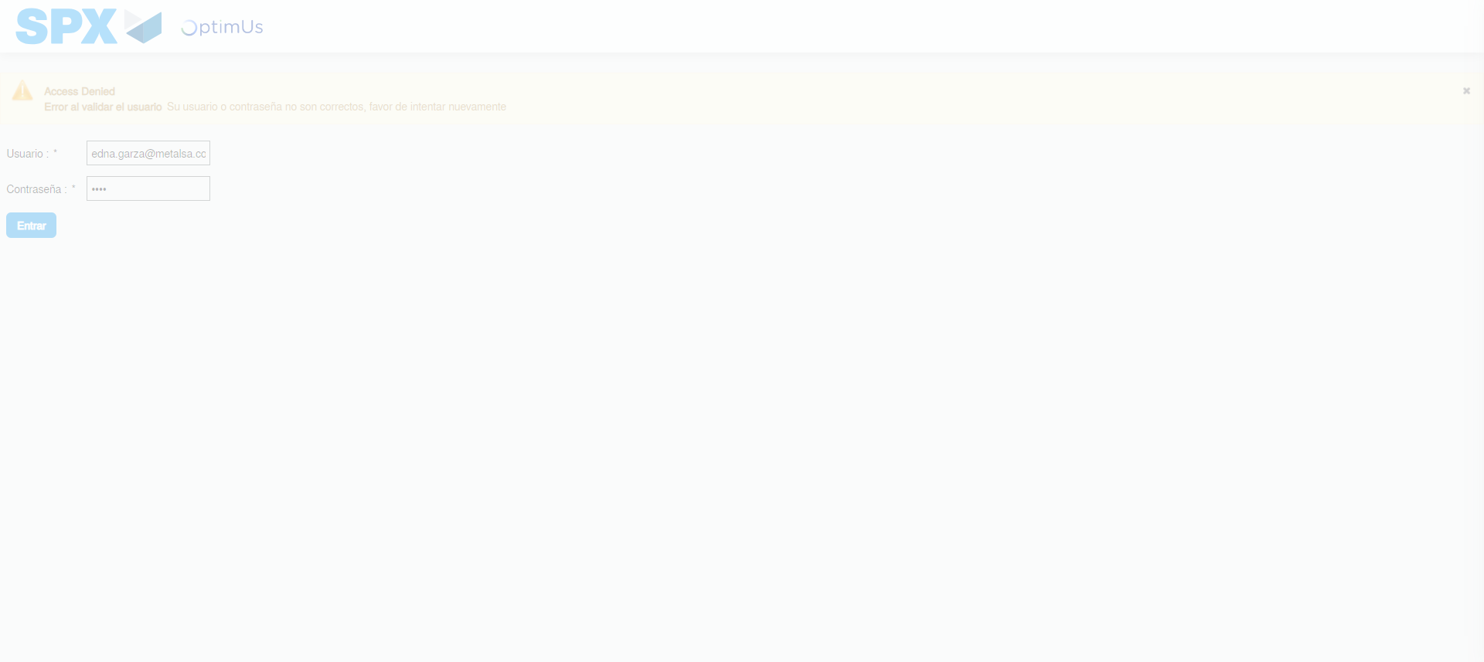Image file-name: QC_Testing-tc004_SPX_Dev5_Validacion_Filtro_Campo_MenuName_Administrador_Menu-may. 15 2024, 01 00 45 p. m.

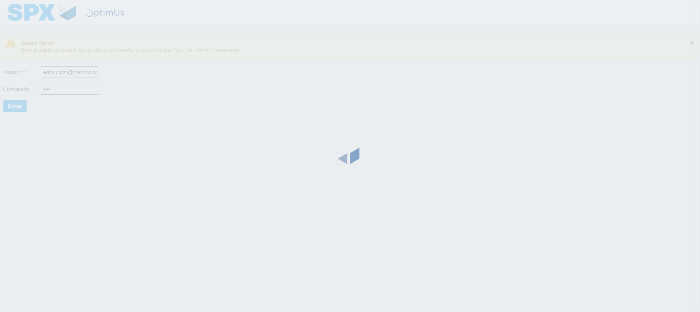Image file-name: QC_Testing-tc004_SPX_Dev5_Validacion_Filtro_Campo_MenuName_Administrador_Menu-may. 15 2024, 01 00 46 p. m.

Step 2 - Select to UEN and Access to Administrador Roles Menu: UEN Correctly selected and Correct access
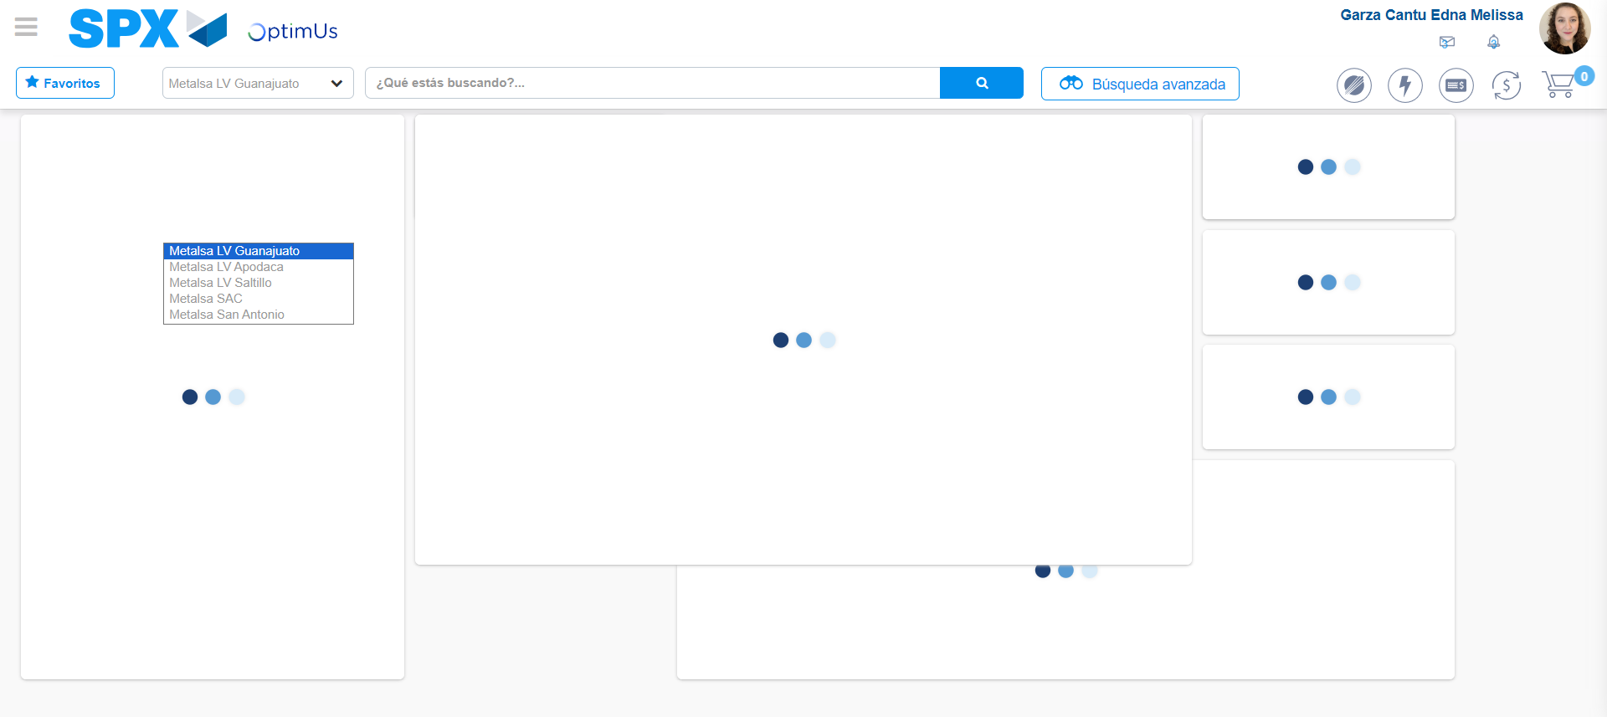Image file-name: QC_Testing-tc004_SPX_Dev5_Validacion_Filtro_Campo_MenuName_Administrador_Menu-may. 15 2024, 01 00 50 p. m.

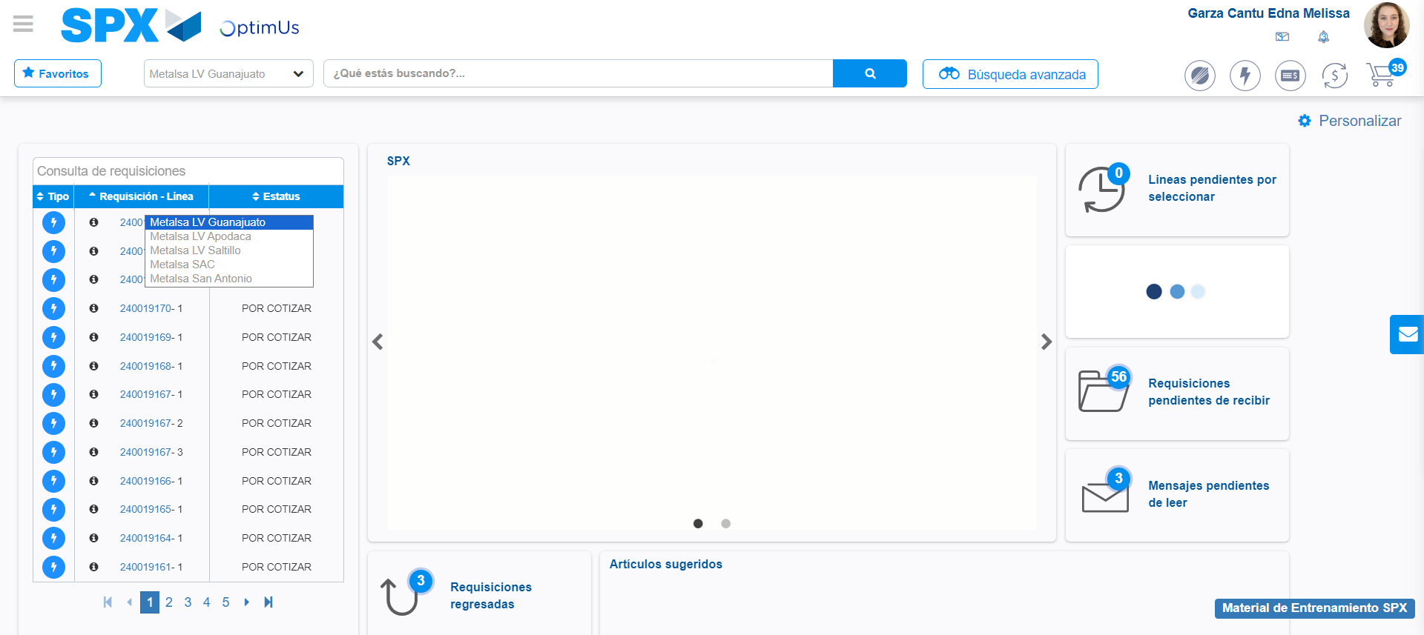Image file-name: QC_Testing-tc004_SPX_Dev5_Validacion_Filtro_Campo_MenuName_Administrador_Menu-may. 15 2024, 01 00 52 p. m.

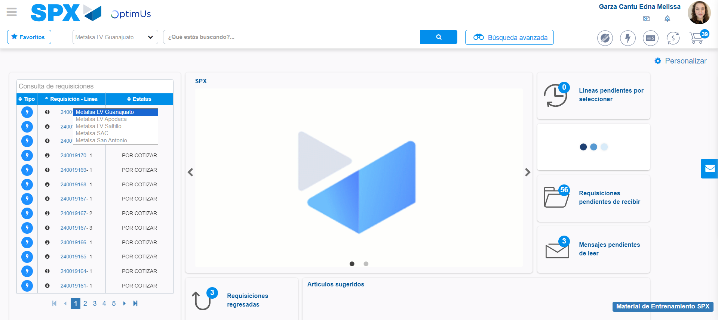Image file-name: QC_Testing-tc004_SPX_Dev5_Validacion_Filtro_Campo_MenuName_Administrador_Menu-may. 15 2024, 01 00 53 p. m.

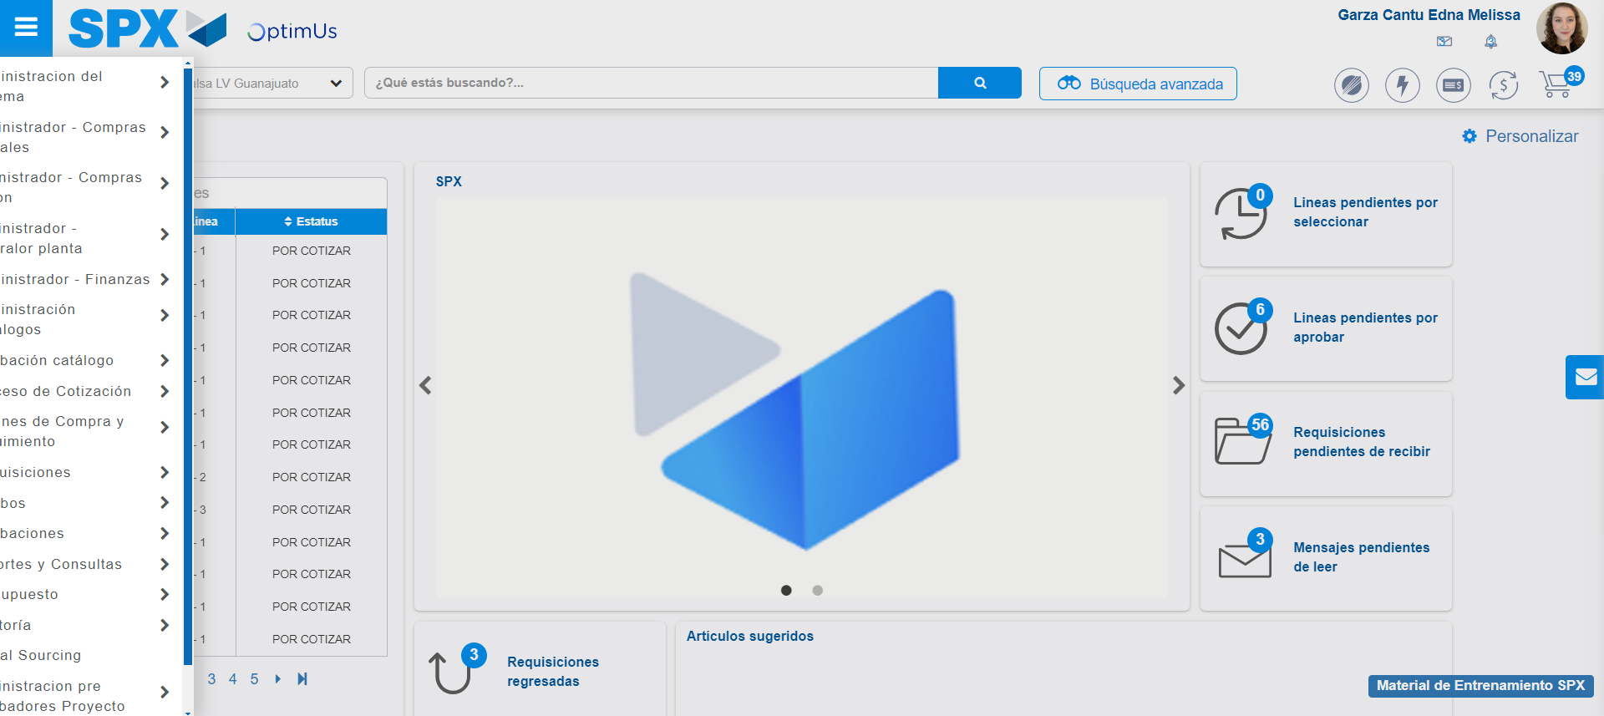Image file-name: QC_Testing-tc004_SPX_Dev5_Validacion_Filtro_Campo_MenuName_Administrador_Menu-may. 15 2024, 01 00 54 p. m.

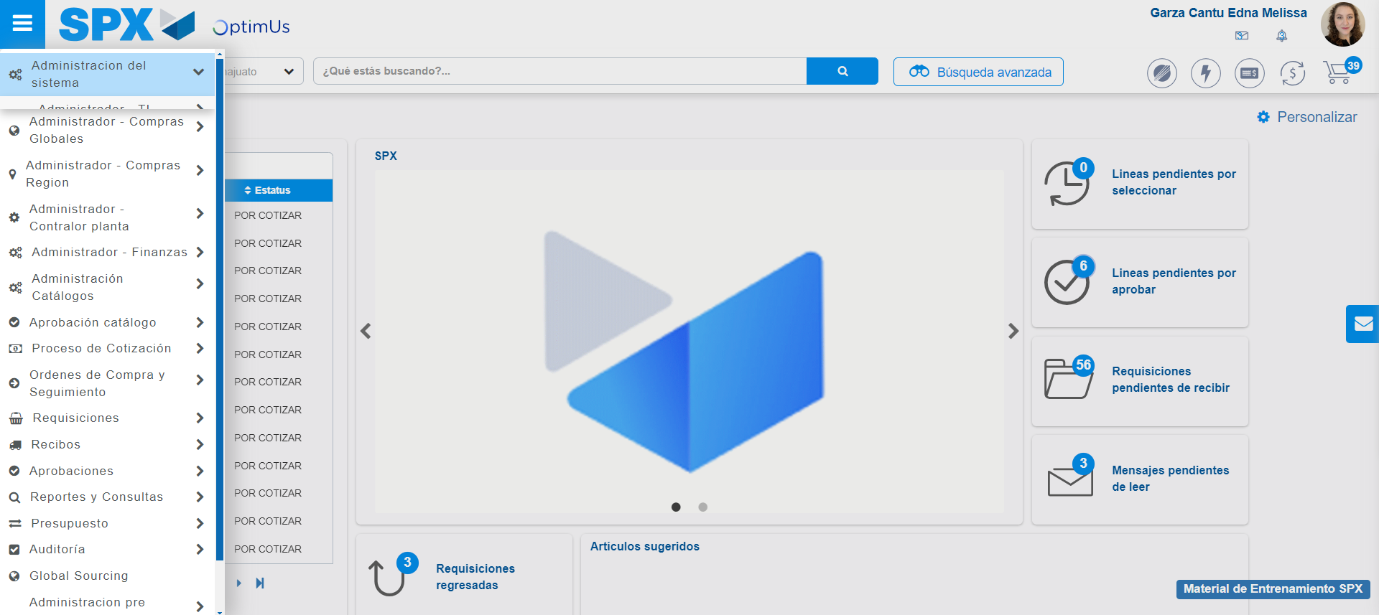Image file-name: QC_Testing-tc004_SPX_Dev5_Validacion_Filtro_Campo_MenuName_Administrador_Menu-may. 15 2024, 01 00 55 p. m.

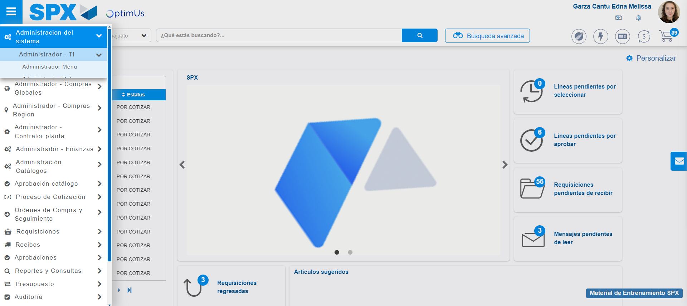Image file-name: QC_Testing-tc004_SPX_Dev5_Validacion_Filtro_Campo_MenuName_Administrador_Menu-may. 15 2024, 01 00 56 p. m.

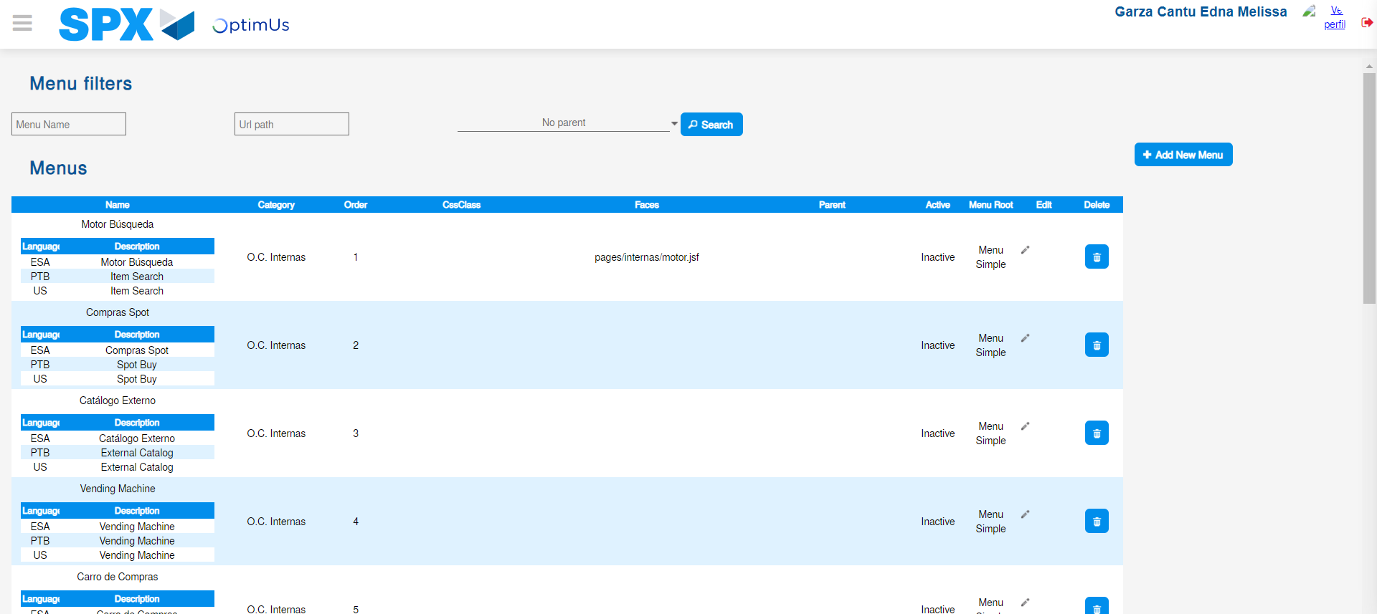Image file-name: QC_Testing-tc004_SPX_Dev5_Validacion_Filtro_Campo_MenuName_Administrador_Menu-may. 15 2024, 01 00 59 p. m.

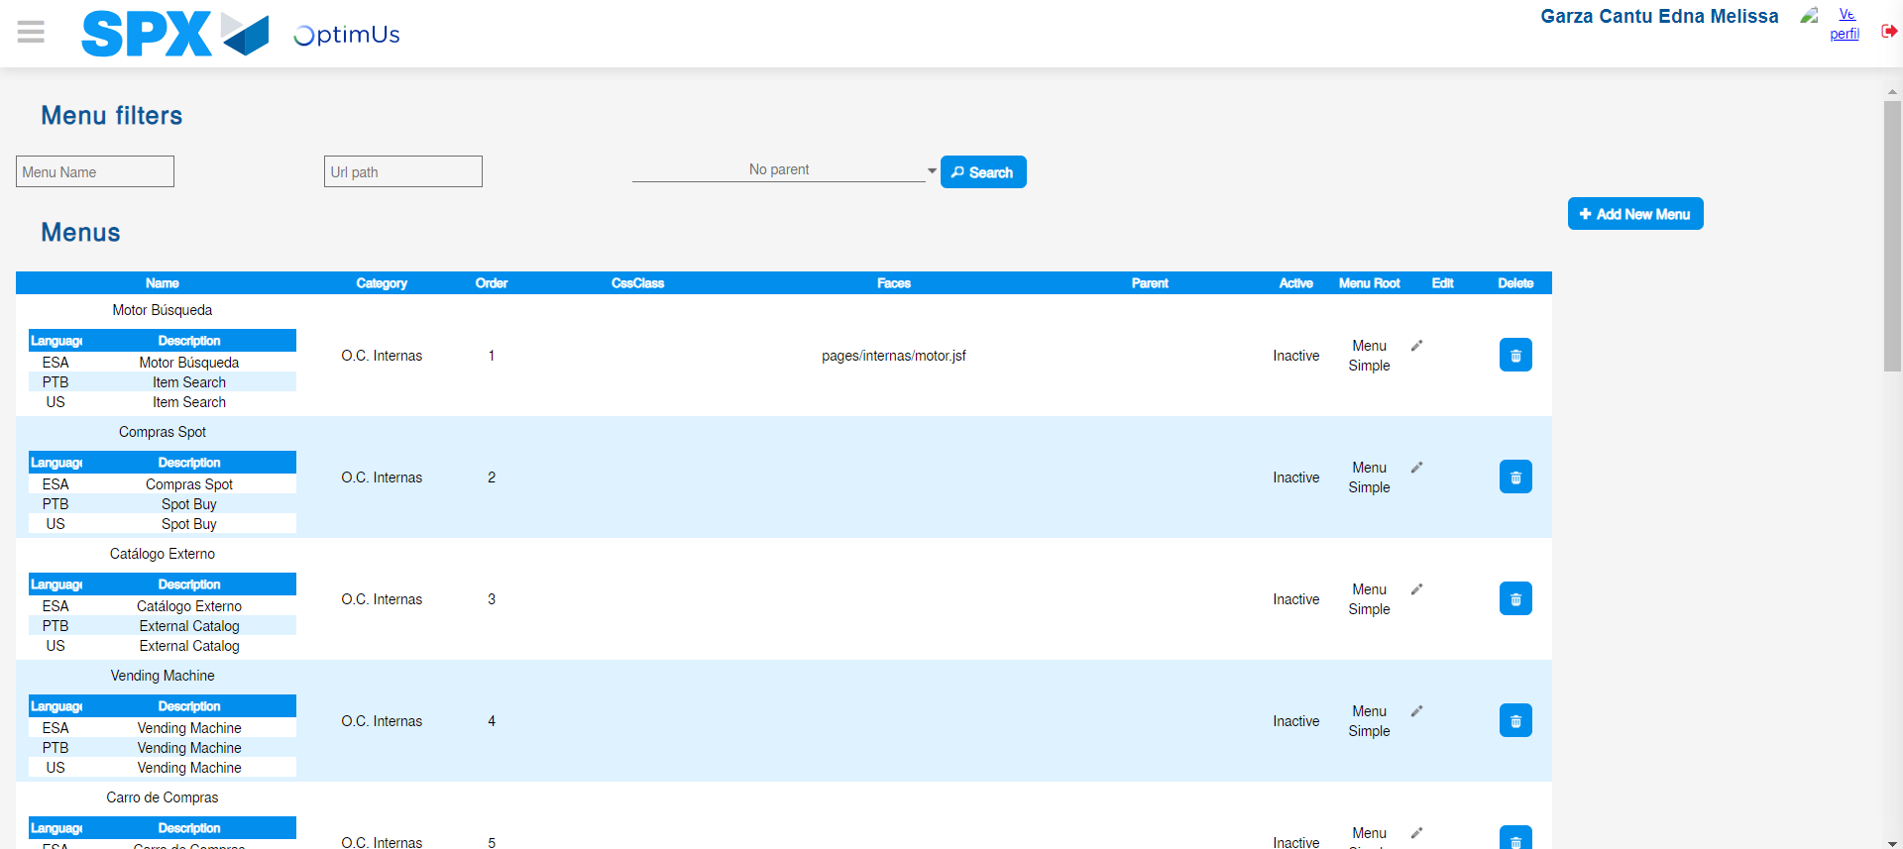Image file-name: QC_Testing-tc004_SPX_Dev5_Validacion_Filtro_Campo_MenuName_Administrador_Menu-may. 15 2024, 01 01 00 p. m.

Step 3 - Perform a search with the Menu Name filter: Successful search
Image file-name: QC_Testing-tc004_SPX_Dev5_Validacion_Filtro_Campo_MenuName_Administrador_Menu-may. 15 2024, 01 01 00 p. m.

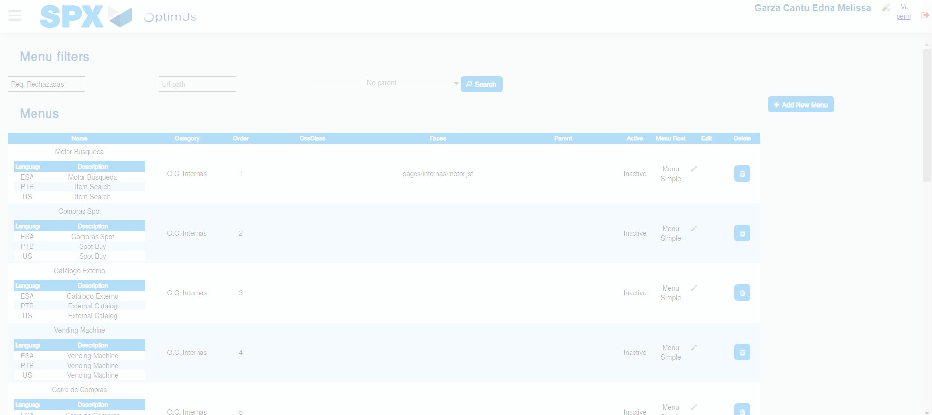Image file-name: QC_Testing-tc004_SPX_Dev5_Validacion_Filtro_Campo_MenuName_Administrador_Menu-may. 15 2024, 01 01 01 p. m.

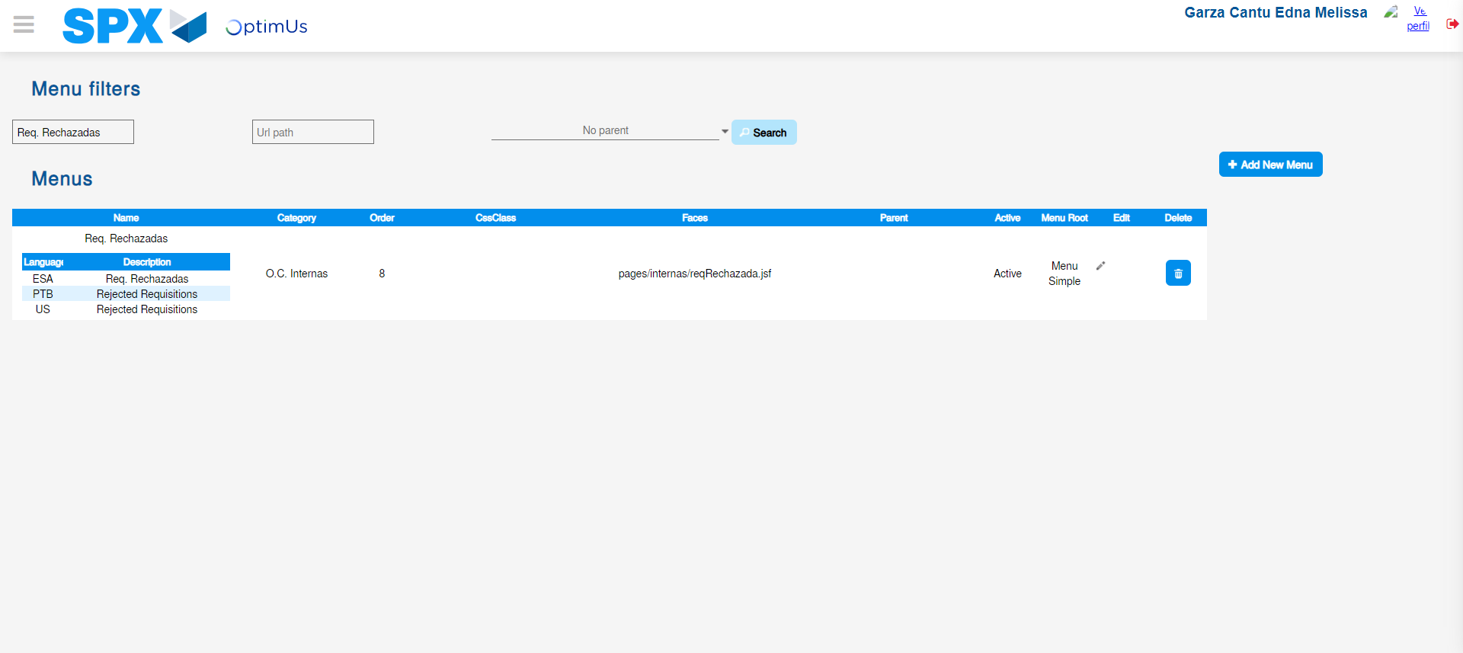Image file-name: QC_Testing-tc004_SPX_Dev5_Validacion_Filtro_Campo_MenuName_Administrador_Menu-may. 15 2024, 01 01 02 p. m.

